**Google Lookalike**

### A MINI-PROJECT REPORT

#### Submitted by

#### G27/T10

**Raghav Kaushal,2210990699**

**Raghav Nagi, 2210990700**

**Raghav Thakur,2210990701**

**Rahul Sharma, 2210990702**

in partial fulfillment for the award of the degree of

## BACHELOR OF ENGINEERING

***in***

COMPUTER SCIENCE & ENGINEERING



**CHITKARA UNIVERSITY**

**CHANDIGARH-PATIALA NATIONAL HIGHWAY**

**RAJPURA (PATIALA) PUNJAB-140401 (INDIA)**

###### TABLE OF CONTENTS

|  |  |  |
| --- | --- | --- |
| **Sr.no** | **Section** | **Page no** |
| 1. | Introduction | 3 |
| 2. | Problem Statement | 4 |
| 3. | Technical Details | 5 |
| 4. | Key Features | 7 |
| 5. | Project Advantages | 8 |
| 6. | Results | 9 |
| 7. | Conclusion and Future scope | 10 |
| 8. | References | 11 |

###### 1. INTRODUCTION *(Abstract)*

1. A Note log list is a list of tasks that need to be completed, typically organized in order of
2. priority. It is one of the simplest solutions for task management and provides a
3. minimal and elegant way for managing tasks a person wishes to accomplish.
4. We aim to design a simple and elegant website for people to keep track of the
5. status of their tasks. Making a Note log list is an easy and important task that everyone
6. should do. The immense satisfaction that one gets when completing the task and
7. marking it on the list is incomparable. Moreover, creating a list of tasks ensure you
8. don’t miss out on anything. It’s a scientific fact that when you write the tasks that you
9. need to complete it, you are even more motivated to complete it. With this in mind, we
10. come to build a platform that will help people create their task lists.
11. With the help of modern tools and technologies, we strive to build a minimal and
12. efficient Note log list which minimizes distractions and helps people achieve the task
13. management with ease and without hassle

A Note log list is a list of tasks that need to be completed, typically organized in order of

priority. It is one of the simplest solutions for task management and provides a

minimal and elegant way for managing tasks a person wishes to accomplish.

We aim to design a simple and elegant website for people to keep track of the

status of their tasks. Making a Note log list is an easy and important task that everyone

should do. The immense satisfaction that one gets when completing the task and

marking it on the list is incomparable. Moreover, creating a list of tasks ensure you

don’t miss out on anything. It’s a scientific fact that when you write the tasks that you

need to complete, you are even more motivated to complete them. With this in mind, we

come to build a platform that will help people create their task list.

With the help of modern tools and technologies, we strive to build a minimal and

efficient Note log list which minimizes distractions and helps people achieve the task

management with ease and without hassle

Google is a simple search engine that helps people to search for various things. It helps people to gather knowledge and information regarding various fields like education, sports, cooking, dancing, singing, and so on.

Google helps us to get up to date with technologies and also helps us to know what things are going around us. It plays an important role in everybody’s life as with the help of Google we can improve ourselves in all fields. Google indexes billions of web pages to allow users to search for the information they desire through the use of keywords and operators. According to ComScore market research from November 2009, Google Search is the dominant search engine in the United States market, with a market share of 65.6%. In May 2017, Google enabled a new "Personal" tab in Google Search, letting users search for content in their Google accounts' various services, including email messages from Gmail and photos.

Google launched its google news service in 2002, an automated service that summarizes news articles from various websites. Google also hosts Google Books, a service that searches the text found in books in its database and shows limited previews or the full book where allowed.

Google has added several features in recent years. Such options include Flights, Shopping, and Finance.

**3. PROBLEM STATEMENT**

Traditionally, the information is gathered from books or the documents or pieces of paper they use to have. But as technology has evolved with time, we have been able to use the internet as a source of knowledge. Google helps people to gather information and knowledge about various things just from one platform. As many times, the books were not available or they were being taken by other people, which is now no longer a problem.

**3. TECHNICAL DETAILS**

**The Front-End technologies that are used to implement this project are:**

The Hypertext Markup Language or HTML is standard markup language for documents designed to be displayed in a web browser

* 1. **HTML-**

.

Use of HTML in the project:

1. <html> represents the root of an HTML document.
2. <head> represents a collection of metadata for doc.
3. <meta> represents various kinds of metadata that can’t be expressed using title, base, link, style.
4. <title> represents document’s title or name
5. <link> allows authors to link their documents to other resources.
6. <body> represents contents of the documents.
7. <h1> represents a section heading
8. <style> allows for quick styling using CSS
9. <div> element is the generic container for flow content
10. <ul> represents unordered list.
11. <li> represents a list item.
12. <footer> creates footer for the sectioning content

CSS or cascading style sheets is used for styling and formatting HTML documents. It is used to define styles for HTML elements such as fonts, colors, spacing and layout.

**3.2 CSS -**

Use of CSS in the project:

1. Inline and internal css has been used to give a proper layout to our website.
2. In adjustment of size and margin of images used using background-size, overflow, height, width, background-size , background-position, margin and more.
3. created an add bar and designed it in such a way that we are able to add our day to day task and also we created an add button using div in html.
4. Horizontal bar containing **All, Completed and Not Completed tasks** and used different font colors and font style.
5. created sticky notes and gave them a proper background image to it by adjusting it's size, margin, width, height, content, color,flex using css.

**3.3 JavaScript-**

JavaScript is a programming language used to add interactivity and functionality to websites. It is commonly used to create dynamic effects, responsive and interactive web pages .

.

* 1. Icon

     Description automatically generated **VS CODE-**

Visual studio code is a free and open-source code editor developed by Microsoft and is designed for building and debugging web and cloud applications.

.

**4. KEY FEATURES**

4.1 Search help: Now there is no worry to find things from different places as the search engine provides all the information from one place

.

4.2 ACCESSIBILITY: Since it is easy to use, there is no need to worry about how to operate it.

4.3 EFFICIENT: It provides quiet efficient information about the thing being searched.

4.4 FREE TO USE: There is no need to pay for use it provides all services for free.

**5. PROJECT ADVANTAGES**

* **The Benefits of Using a Search Engine: -**
* **Improves your knowledge:** It provides you with a lot of information about all fields to improve your knowledge.
* **Increases productivity**: In less time one can learn various things in less time as the individuals don’t have to move to various places for different things.

**6. OUTPUT**

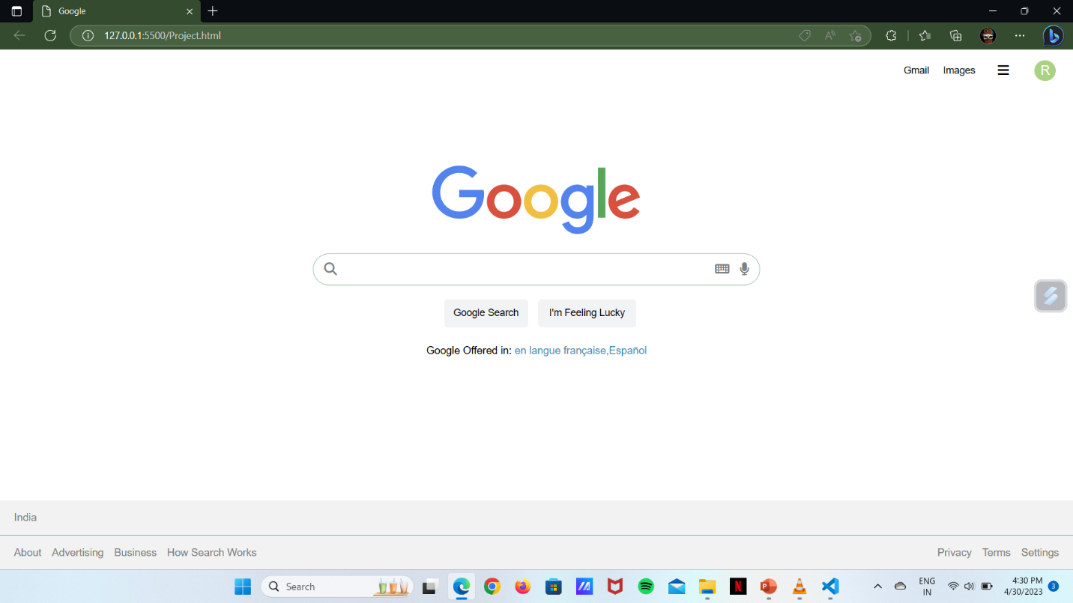

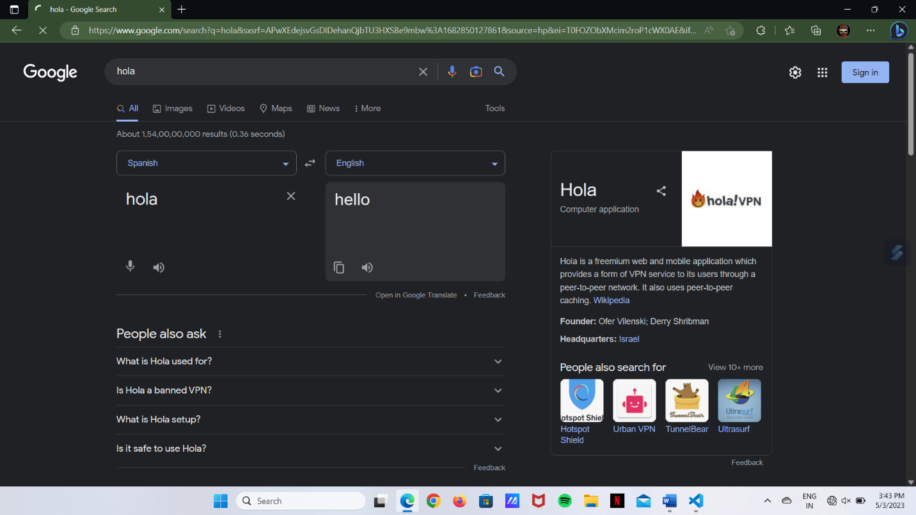

**8. REFERENCES**

1. https://en.wikipedia.org/wiki/HTML
2. www.w3 schools.com
3. google
4. youtube
5. geekforgeeks
6. Font Awesome